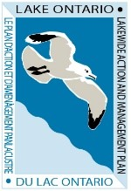
Let’s Talk Lake Ontario
Stemming the Tide: Addressing Invasive Plants Around Lake Ontario
Hosted by the Lake Ontario Partnership
Wednesday, June 12, 2024; 12 - 1 p.m. ET

AGENDA
12:00 – 12:05 | Welcome Ryan Elliott, New York State Department of Environmental Conservation
12:05 – 12:20 | Invasive aquatic species and especially plants in Lake Ontario Catherine McGlynn, New York State Department of Environmental Conservation
12:20 – 12:25 | Audience Q&A #1
12:25 – 12:35 | Discovery of Hydrilla in the Niagara River Lindsay Yoder, New York State Department of Environmental Conservation
12:35 – 12:45 | Addressing invasive Water Soldier: impacts, prevention and response Mary Gunning, Quinte Conservation (Ontario)
12:45 – 12:55 | Audience Q&A #2
12:55 – 1:00 | News you can use: What you can do to prevent the spread of aquatic invasive species in Lake Ontario

